

**LMS Analytics Strategy and**

**Predictive Performance Reporting for**

**Rychtenshane Community Housing Group**

**Prepared By :**

**Joefer Cosio, Kousar Saleem, Mariel Palacio, Vineet Khurana**

**Table of Contents**

**Executive Summary:** 3

**Learning & Compliance Performance Insights** 3

Insight Narratives: Trends, Risks, and Opportunities Derived from the Dashboard 4

**Advanced Analytics** 7

**1. Forecasting: Predict Training Completions** 7

**2- Regression Analysis: Impact of Training Time and Frequency on Performance Scores** 11

**3- ANOVA Analysis: Evaluating Performance Score Variability Across Teams** 12

**Team Collaboration & Project Reflection** 14

**Strategic Recommendations** 19

**KPIs** 20

**Growth Opportunity** 20

## **Executive Summary:**

## **Learning & Compliance Performance Insights**

**Key Strengths**

* **High Engagement in Mandatory Courses:** Mandatory courses show stronger engagement (80% completion) compared to regular courses (78%), despite being significantly more in volume (1,709 vs. 291).
* **Trafford Branch Leads in performance:** Trafford leads in both course completion (418 courses) and lowest overdue rate, indicating strong compliance culture and learning engagement.
* **Strong Role-Based Performance:** Network Technicians lead in performance (85% completion, 15% overdue), with Maintenance Technical and Support roles showing highest skill scores.
* **Finance Course Excellence:** Finance category boasts the highest completion (87%) and lowest overdue (13%), with a strong average skill score (3.07) and performance score (80.71), showcasing domain strength.
* **Q4 Shows Consistent Performance**: Despite other quarters having higher course completions, Q4 has the lowest average overdue courses (93**)**, suggesting improved end-of-year learning accountability and completion urgency.

**Key Weaknesses**

* **Rocky Start in 2025 and Q1 Overdue:** 2025 shows a weaker LMS engagement trend, especially in Q1. This disrupts the usual trend where Q2 typically performs best, and signals a need for a year-start compliance push.
* **Compliance Courses Lag:** Compliance has the lowest completion rate (77%) and highest overdue (23%). Payroll compliance is a critical weak spot (73% completion, 27% overdue).
* **Skill Gaps Persist in High-Demand Roles:** Despite high learning hours, IT roles show the highest skill gaps (e.g., IT Support Officer: 118), and System Analysts record the lowest average score (78) and skill score (2.92).
* **Wythenshawe Central Underperformance:** This location shows lowest course completion, highest overdue, lowest skill score (2.98), and least time spent learning—requiring immediate intervention.
* **Disparity in Course Allocation Across Teams:** Facilities team has significantly fewer courses assigned (276) and lowest LMS hours (349), yet show high completion and lower skill gaps, indicating inconsistent expectations across teams.
* **Underutilization of Mobile and Screen Readers:** Desktop is dominant (919 hrs) vs. mobile (782 hrs). Screen reader usage, though beneficial, is underused in essential training areas (e.g., cybersecurity, onboarding).

## Insight Narratives: Trends, Risks, and Opportunities Derived from the Dashboard

This section summarizes the analytical observations from our Power BI dashboard, built on enriched LMS data.  The narratives are categorized under three main pillars: Trends, Risks, and Opportunities.

**1. Trends**

* **Overall Training Engagement:**With 2000 total courses taken and an 80% overall completion rate, the organization demonstrates strong engagement with mandatory training. IT and Facilities departments lead with over 82% course completion, indicating well-established compliance habits in technical teams.
* **Quarterly Completion Patterns:**From 2018 to 2024, completions have generally trended upward, peaking in Q1 2024 (101 completions). However, a sharp decline is seen in 2025, with completions dropping to 12 by Q1 highlighting a sudden disruption in training participation.
* **Role-Based Completion Patterns:**The highest-performing roles (Network Technician, Facilities Manager, Cleaner,) maintain 83–85% completion, while Payroll Specialist, Maintenance Technicians, and Plumbers show the lowest engagement (~78–80%). This suggests a need for more targeted interventions for field-based roles.
* **Location-Wise Uniformity:**Completion rates are consistent across sites (mostly at 80%), with the Trafford Branch slightly outperforming others (81%).
* **Role and Team-Specific Skill Distribution:**Most roles and teams maintain average skill scores close to 3.0–3.1. Notably, Maintenance Technicians (3.13), Support Specialists (3.10) and Payroll Specialists (3.08) show relatively higher skill levels, while Electricians (2.90) and System Analyst (2.92) lag slightly.
* **Course Quality Variation:**Courses such as “Health & Safety” (3.30) and “Customer Service” (3.09) receive higher skill ratings, suggesting they are more impactful. On the other hand, “Safeguarding Adults” (2.80) and “Cleaning” (2.89) appear to have less perceived or actual skill improvement.
* **Skill Gap Centralization in IT and Compliance:**IT has the highest skill gap count (309 gaps in Team), followed by Compliance and Systems Training(413 in category). This indicates that technical and regulatory domains face greater challenges in knowledge retention or application.
* **Balanced Engagement Across Devices**Engagement is spread fairly evenly across Desktop (35.87%), Tablet (32.48%), and Mobile (31.66%), demonstrating flexibility in how employees access learning.
* **Steady Average Engagement Time**The average learner engagement sits at ~75 minutes per course and ~77 days between enrollment and last access, suggesting long but spaced learning durations, possibly due to work interruptions or part-time learning culture.
* **Accessibility and Inclusion**21% of users rely on screen readers, and they demonstrate higher average scores (81.08 vs. 79.88) and stronger feedback ratings. This reflects positively on the inclusiveness and usability of the LMS platform for visually impaired users.
* **Stable Yet Seasonal Completion Patterns**Training completions steadily increased from 2018 to 2024, with visible seasonal dips and surges (notably Q2 drops and Q4 peaks). Forecasting predicts a modest rebound after a sharp drop in early 2025, suggesting cyclical fluctuations may persist into 2026–2027.

**2. Risks**

* **2025 Training Drop-Off:**The sharp decline in course completions in Q1 and Q2 2025 is concerning. Despite historical engagement, only 12 completions occurred in Q1 possibly due to policy changes or workloads. This drop poses risks to compliance and performance continuity.
* **Overdue Course Backlog:**Roughly 20% of assigned courses remain overdue. Which may erode completion momentum and compromise team readiness.
* **Delayed Completion Time:**The average time to complete a course stands at 32 days a relatively long window. Prolonged completion cycles might indicate scheduling conflicts or insufficient training prioritization.
* **Disengagement Among Certain Roles:**Lower course completion among certain field roles (e.g., Payroll Specialist, Finance Analyst) indicates uneven motivation or access issues. Without intervention, this could widen future skill gaps.
* **Underperformance in Specific Roles and Courses:**Roles like Electricians and Systems Analysts show low average scores (2.90–2.92). Similarly, courses like “Data Protection” and “Cybersecurity Essentials” show relatively poor performance, despite their regulatory importance.
* **Under-engaged Roles**

Facilities Managers spent only 80 hours total, significantly less than peers. This under-engagement could lead to skill depreciation and lower compliance.

* **Lag in Systematic Feedback or Monitoring**

Enrollment vs. last access indicates a long tail of extended inactivity, suggesting courses often remain open far beyond their intended engagement periods.

**3. Opportunities**

* **Early Warning System:**Monitoring overdue percentages and sudden quarterly dips can serve as early indicators of organizational disengagement. Alerts or automated nudges can help mitigate emerging training gaps.
* **Targeted Coaching for Bottom Roles:**Custom strategies such as hands-on workshops, role-specific microlearning, or supervisor nudges could uplift low-performing roles, especially among field teams.
* **Faster Time-to-Completion Campaigns:**Streamlining access, setting micro-deadlines, or incentivizing early completion can reduce the 36-day average training time and boost responsiveness.
* **Expand High-Performance Practices:**Teams and roles with the highest completion rates (e.g., IT Support, Facilities) could serve as case studies to replicate their strategies across other teams.
* **Dashboard-Driven Planning:**Continued use of dashboards enables real-time insights and proactive training management, supporting strategic HR planning and performance interventions.
* **Focus Learning on Low-Performing Courses & Roles:**Low-score courses can be revised using engaging formats (e.g., scenario-based learning, gamification). Underperforming roles could benefit from mentorship, job aids, or blended learning.
* **Location-Based Optimization:**Civic Centre Hub shows the highest average skill score (3.06); their training practices could be audited and adapted to raise scores across other sites.
* **Location-Based Optimization:**Civic Centre Hub shows the highest average skill score, their training practices could be audited and adapted to raise scores across other sites.
* **Mobile-First Enhancements**Given that ~32% of users prefer mobile, optimizing training modules for mobile-first learning (bite-sized content, offline access) could increase completion rates and reduce overdue percentages.

**Course Optimization Using Forecast and Regression Models** Use forecasting outputs to plan course delivery around seasonal dips and adjust curriculum based on regression insights, possibly refining course length, pacing, or interactivity to drive performance improvement.

## **Advanced Analytics**

This section provides a comprehensive statistical analysis of training patterns and their potential impact on employee performance. The key components analyzed include forecasting training completions, regression analysis of performance scores, and ANOVA tests to compare skill differences across teams.

## **1. Forecasting: Predict Training Completions**

In this section, we aimed to analyze historical training completion trends and build forecasting models to predict future completions. Accurate forecasting supports proactive training resource allocation and organizational planning.

**1.1. Quarterly Forecast (Next Quarter – SARIMA)**

We first modelled the number of quarterly training completions using a Seasonal ARIMA (SARIMA) model, trained on historical completions from 2018 to mid-2025. The goal was to predict the number of courses expected to be completed in Q3 2025.

* Model Used: SARIMA
* Forecasted Quarter: Q3 2025 (2025-09-30)
* Predicted Completions: 27.46

This result is visualized below, where the SARIMA forecast is compared against historical quarterly completions:

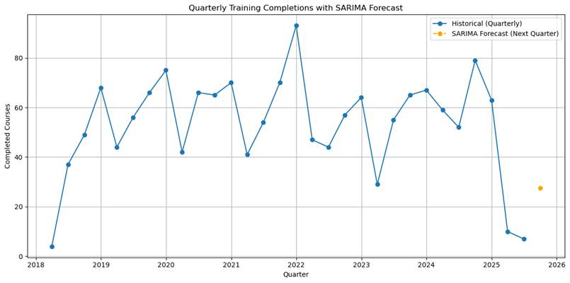 

**1.2. Multi-Quarter Forecast (Q3 2025 to Q4 2026 – SARIMA)**

Next, we extended the SARIMA model to forecast completions for the next six quarters (Q3 2025 through Q4 2026). This helped us understand how completions might trend beyond the immediate quarter.

|  |  |
| --- | --- |
| **Quarter** | **Forecasted Completions** |
| 2025-09-30 | 27.46 |
| 2025-12-31 | 34.97 |
| 2026-03-31 | 11.35 |
| 2026-06-30 | 25.79 |
| 2026-09-30 | 46.44 |
| 2026-12-31 | 45.83 |

This extended forecast is visualized in the graph below:

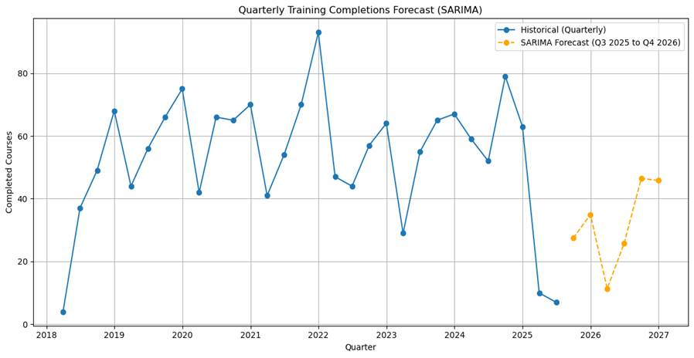

**1.3. Yearly Forecast (Next Year – SARIMA)**

To capture longer-term trends, we also aggregated historical completions by year and trained a SARIMA model on this yearly series. The objective was to predict the total number of training completions expected in 2026.

Predicted Completions for 2026 = 199.57

This forecast is visualized below:

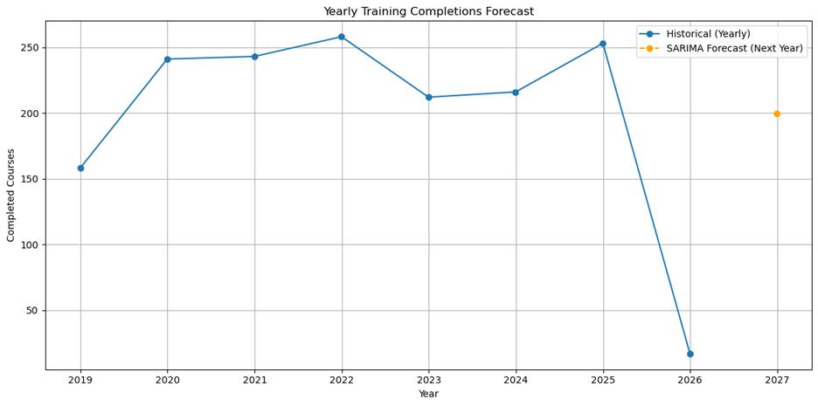



**1.4. Model Comparison: SARIMA vs Prophet vs Actual**

In addition to SARIMA, we implemented Facebook’s Prophet model on the same quarterly dataset to compare predictive performance. The forecasts were benchmarked against actual training completions from Q1 2023 to Q2 2025.

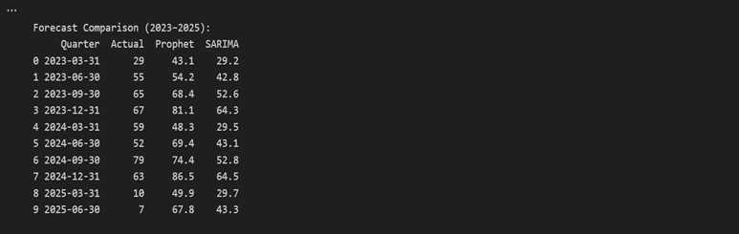

The visual comparison of all three series is shown below:

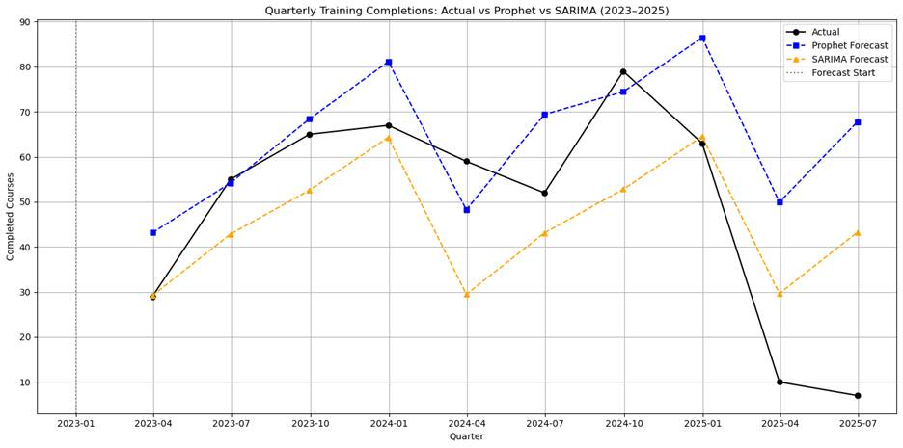

**1.5 Interpretation**

The SARIMA model produced strong short-term forecasts, particularly aligning closely with actual completions in earlier quarters such as Q1 and Q3 of 2023. Notably, SARIMA handled the sharp decline in training completions during 2025 better than Prophet, making it more accurate during periods of unexpected downturn.

On the other hand, the Prophet model demonstrated greater flexibility in capturing overall growth trends but consistently overestimated completions throughout 2024 and 2025. It failed to anticipate the steep drop to just 10 and 7 completions in early and mid-2025, resulting in significantly larger forecast errors than SARIMA during those periods.

Training completion rates are highly seasonal, with clear fluctuations across quarters peaking mid-year and declining sharply in 2025.

Sudden dips in completions (e.g., Q1 and Q2 of 2025) indicating that external organizational or policy shifts (e.g., budget constraints, onboarding cycles, or system changes) may have influenced participation.

## **2- Regression Analysis: Impact of Training Time and Frequency on Performance Scores**

**2.1 Objective**

This analysis investigates how two key training variables training duration and course frequency influence overall employee performance. By fitting a linear regression model, we aim to quantify the relationship between:

* DurationMinutes: Total time (in minutes) an employee spent on completed training.
* CourseFrequency: Number of completed courses by an employee.
* CombinedPerformance (target variable): Average of three skill assessment scores and a normalized training score, all scaled to a 0–5 range:
  + Communication
  + Technical Efficiency
  + Teamwork
  + Score (scaled down from 100 to 5)

**2.2 Model Results**

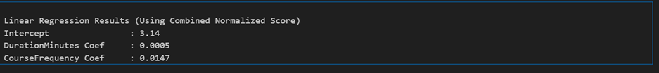

**2.3 Interpretation**

* DurationMinutes (0.0005): Every additional minute of training is associated with an average increase of 0.0005 points in the overall performance score. While the coefficient is small, it suggests a positive linear relationship longer training durations slightly contribute to better outcomes.
* CourseFrequency (0.0147): Each additional completed course leads to an estimated 0.0147 point increase in performance. This coefficient is more substantial than that for duration, implying that completing more courses may be a stronger predictor of improved performance than time alone.

**2.4 Conclusion & Recommendations**

The regression analysis confirms that both training duration and course frequency positively influence performance, though the effect sizes are modest. Course frequency appears to be a more meaningful predictor than total duration, hinting that variety or repetition of learning may matter more than total time investment. From a policy perspective: 1- Encourage structured multi-course training paths rather than isolated long-duration courses. 2- Monitor and optimize training hours to ensure time spent translates into measurable performance gains.

## **3- ANOVA Analysis: Evaluating Performance Score Variability Across Teams**

To investigate whether employee performance significantly differs across organizational teams, we conducted a one-way Analysis of Variance (ANOVA). This method tests if the mean performance scores across multiple groups (teams) vary in a statistically meaningful way.

**3.1 Objective**

Determine whether performance score disparities exist across departments, suggesting potential differences in training effectiveness or team-level dynamics.

In methodology, each employee's average performance score was calculated as the mean of:

· SkillScore_Communication

· SkillScore_TechEfficiency

· SkillScore_Teamwork

**3.2 Results**

|  |  |  |  |
| --- | --- | --- | --- |
| **Skill Area** | **F-statistic** | **P-value** | **Conclusion** |
| Communication | 1.31 | 0.2554 | No significant difference across teams |
| Technical Efficiency | 0.18 | 0.9688 | No significant difference across teams |
| Teamwork | 0.33 | 0.8974 | No significant difference across teams |
| Overall Performance | 0.79 | 0.5560 | No significant difference across teams |

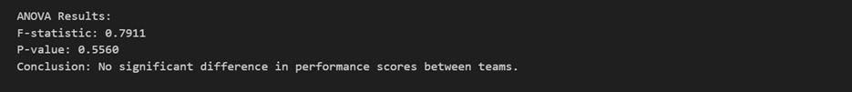

**3.3 Visual Insights**

* The boxplot as shown in figure illustrates the performance score distribution by team, showing consistent median scores and interquartile ranges across all departments.

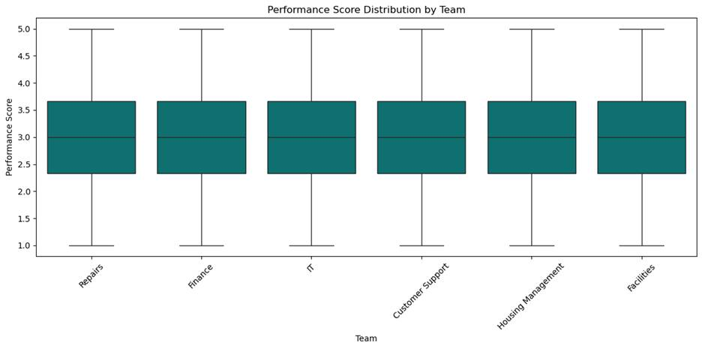

* The heatmap (Figure below) displays the average skill scores per team. While some variations are visible (e.g., slightly higher communication scores in Customer Support), these differences were not statistically significant.

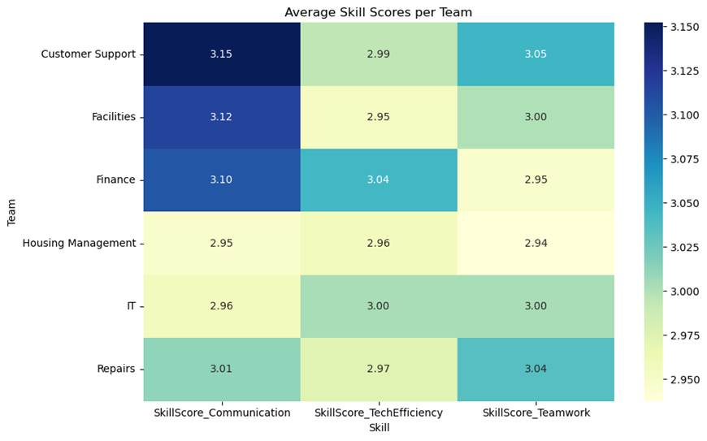

**3.4 Interpretation**

The p-values for all skill areas and overall performance scores were above the 0.05 threshold, indicating no statistically significant difference in performance scores between teams. This suggests a consistent training and skill development experience across departments, with no team outperforming or underperforming significantly on average.

**3.5 Conclusion**

Based on the ANOVA results, we conclude that employee performance in terms of communication, technical efficiency, and teamwork is uniform across teams. This reinforces the notion that the training program offers a balanced impact regardless of departmental assignment.

## **Team Collaboration & Project Reflection**

**Team Roles & Division of work, Strengths, Weakness**

|  |  |  |  |  |
| --- | --- | --- | --- | --- |
| Team Members | Responsibilities | Responsibility Reason | Strengths | Weakness |
| Joefer Cosio | Project Organizer, Power BI Reporting, Github Submission | Expertise, Interest | Excel, Power BI, Leadership skills | Python |
| Kousar Saleem | Data Cleaning and Statistical Analysis, Report Creation | Expertise, Interest | Excel, SQL, Python | Power BI |
| Mariel Palacio | Statistical Analysis, Github Readme | Expertise, Interest | Python | SQL |
| Vineet Khurana | Data Modelling, Report Creation | Expertise, Interest | Excel, Power BI | Python |

**Workflow methodology**

* We used ***Kanban Methodology*** and created a project on Github to share and track the tasks. We also created an excel worksheet to track the tasks.

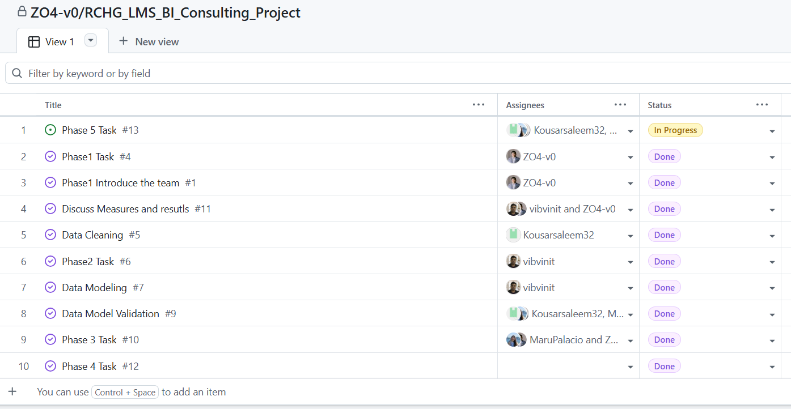

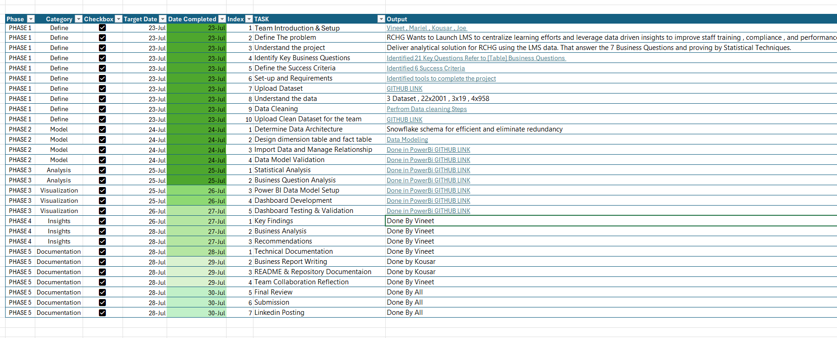

**Collaboration tools**

* Slack

**(Screenshot of few conversations)**

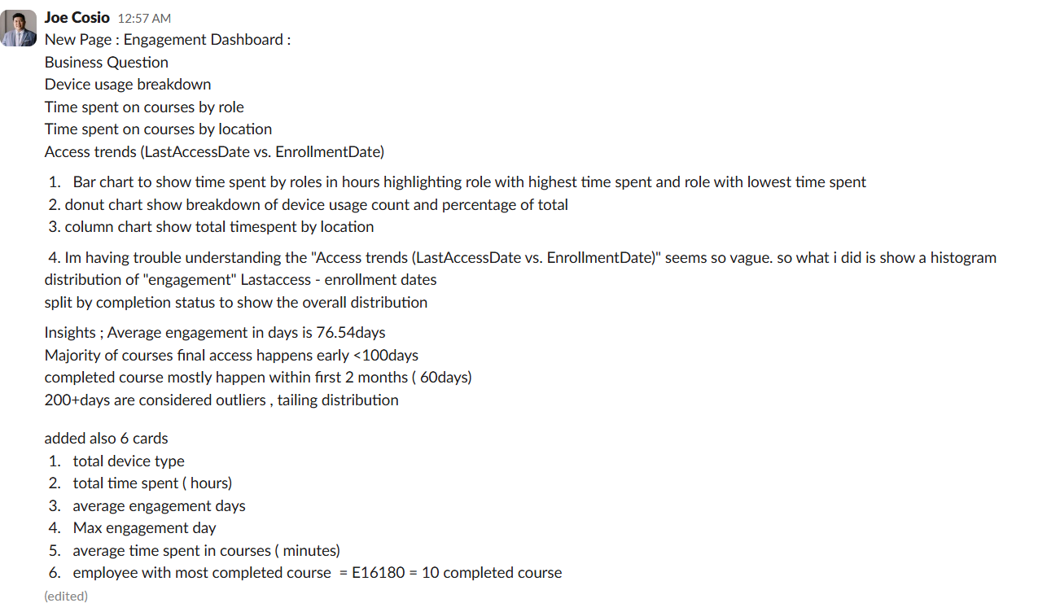

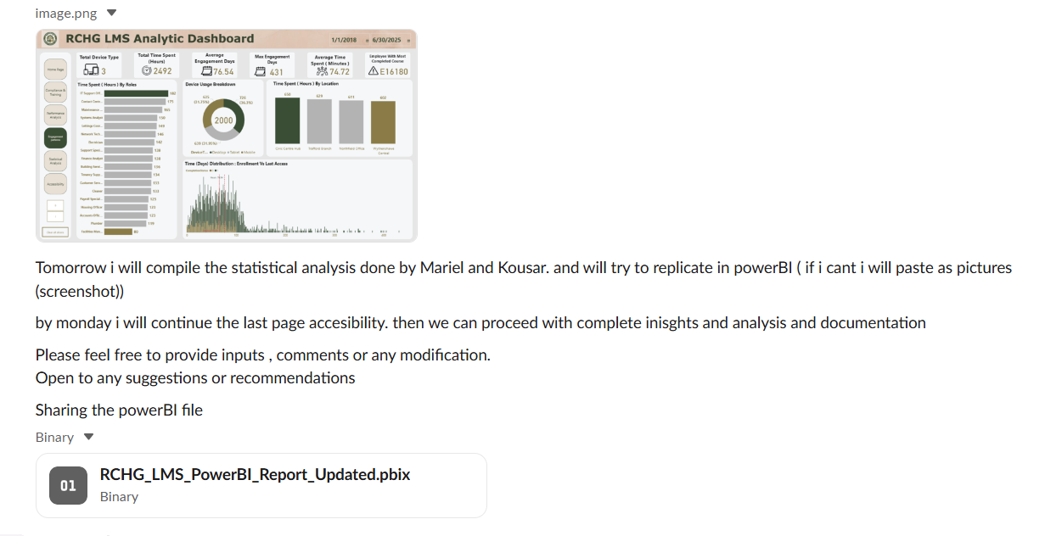

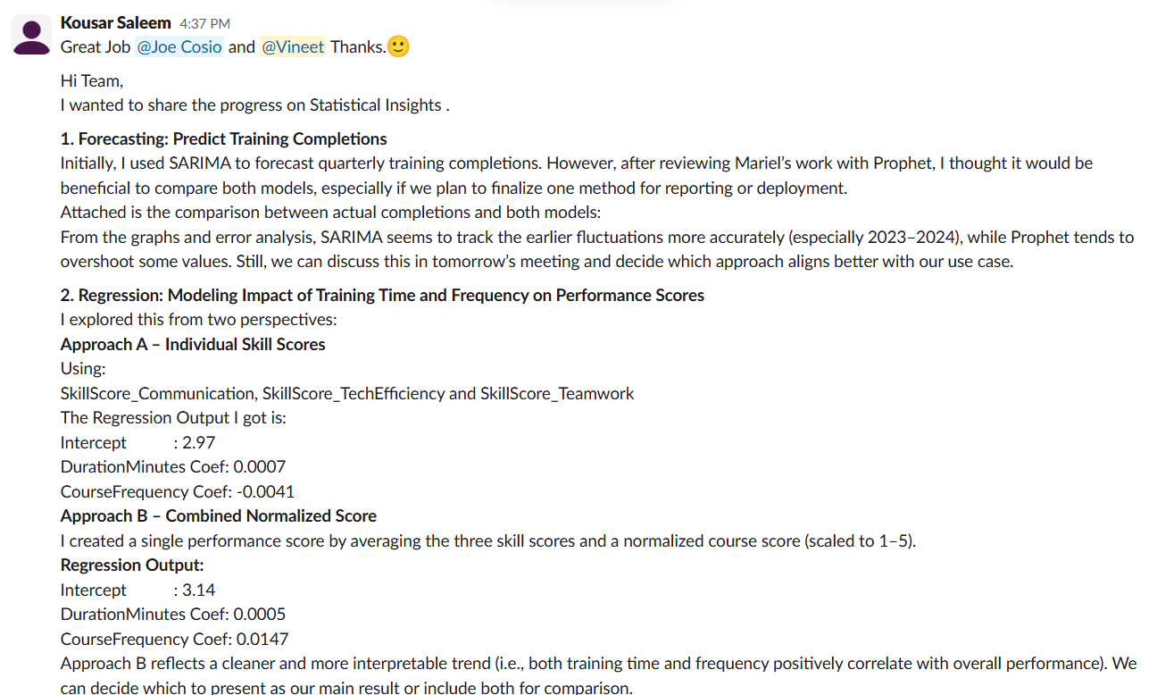

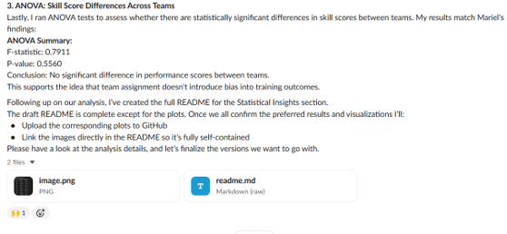

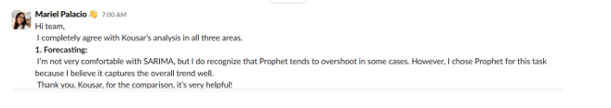

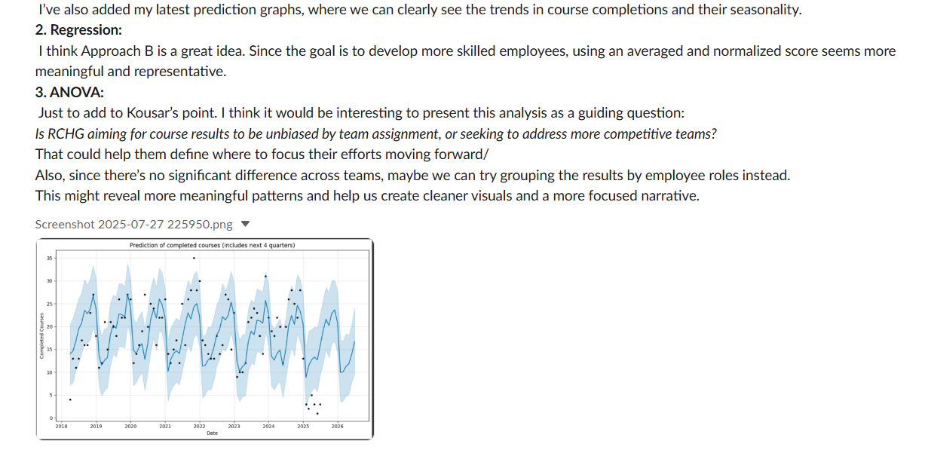

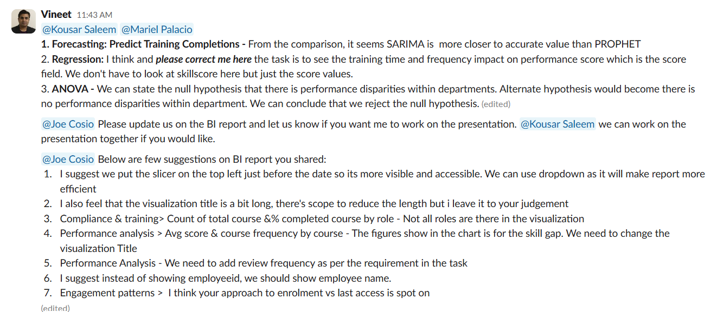

**Challenges Faced**

* **Time Zone and Availability Constraints:** Coordinating across different time zones and aligning with everyone’s availability posed a challenge in making timely decisions and finalizing tasks. To overcome this, we leveraged collaboration tools such as Slack and Microsoft Excel to delegate responsibilities, maintain visibility on task progress, and ensure asynchronous communication was effective.
* **Dataset Quality and Alignment:** The initial dataset provided had inconsistencies and, upon cleaning, did not yield meaningful insights. This issue was promptly raised, and a revised dataset was shared, which resolved the misalignment and allowed the team to proceed with analysis.

**Lessons Learned**

* **Adaptability:** Working in a team often requires flexibility—not only in terms of schedules but also in adapting to different viewpoints. Balancing individual contributions with team consensus was key to driving the project forward.
* **Communication:** Establishing clear communication channels and selecting the right tools is critical, especially when working remotely or across different time zones. Proactive updates and regular check-ins significantly improved collaboration and clarity.
* **Leverage on Team Strengths:** Each team member brought unique skills and perspectives. Recognizing and utilizing these strengths helped us divide tasks more efficiently and deliver higher-quality results.
* **Improving technical skills:** The project provided a valuable opportunity to enhance technical capabilities, particularly in statistical analysis and data interpretation, which contributed to both personal and team growth.

## **Strategic Recommendations**

**1. Address Compliance Category Gaps Proactively**

* Prioritize Payroll Compliance and Finance team compliance performance with dedicated refreshers, tracked deadlines, and automated follow-ups.
* Consider segmenting compliance training by risk/criticality level to better align content with learner relevance.

**2. Boost Q1 and Start-of-Year Learning Engagement**

* Launch quarterly campaigns or learning challenges to combat Q1 inertia and avoid backloading completions into Q4.
* Include manager-level nudges or KPI integration to foster accountability early in the year.

**3. Strengthen Underperforming Roles and Locations**

* Deploy focused training interventions for Wythenshawe Central and System Analysts, including skill-specific mentoring or diagnostics.
* Apply best practices from Trafford and Network Technicians as internal benchmarks.

**4. Standardize Training Load Across Teams**

* Conduct a course load audit to ensure equitable and role-appropriate distribution across teams like Facilities, Repairs, and Customer Support.

**5. Enhance Learning Accessibility & Mobility**

* Optimize LMS design for mobile responsiveness and screen reader integration, especially in high-risk or onboarding courses.
* Track accessibility usage trends and promote tools to employees needing additional learning support.

**6. Implement Role-Based Learning Pathways**

* Develop structured learning journeys tailored to each role or department, especially those with high skill gaps (e.g., IT Support, System Analyst, Repairs)

**7. Introduce Learning Accountability Dashboards**

* Develop manager-level dashboards that display their team's course completion rates, overdue status, skill scores, and time spent on LMS.
* Incorporate learning metrics into monthly team reviews and performance discussions. Recognize top performers and flag underperformance early.

## **KPIs**

**Below are the recommended KPIs:**

* Completion Rate by team / by employee
* Overdue Rate by team / by employee /
* Avg Completion Time(days) by employee
* Learning Hours by team / by employee
* Skill Gap by team
* Performance score by team / by employee
* Skillscore by team/ by employee
* Course Feedback Rating

**Below are suggested key drivers to make this success:**

* Define and track the KPIs every Quarter.
* Let manager drive the KPI performance
* Build a dashboard for manager to track performance
* Make this a part of performance review and one of the promotion criteria.

## **Growth Opportunity**

By leveraging high-performing areas and applying focused strategies to underperforming quarters, roles, and categories, the company can build a more consistent, accessible, and high-impact learning culture. A quarterly pulse check, improved training design, and role-specific engagement plans will enable sustainable compliance growth and skills development.